Laudato Si’ and the Path to COP22
September 28, 2016, Casina Pio IV, Vatican City
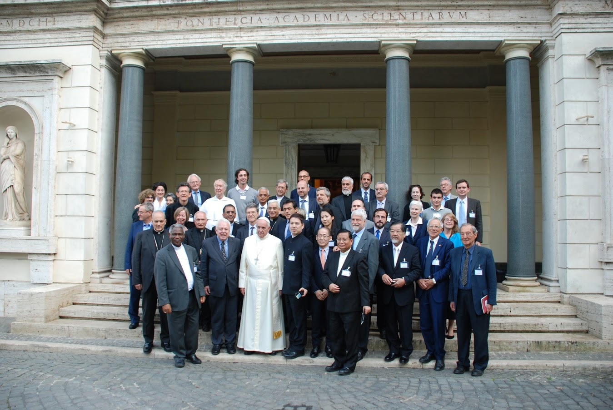
Pope Francis joined the conference at the end of the day.
“Many things have to change course, but it is we human beings above all who need to change. We lack an awareness of our common origin, of our mutual belonging, and of a future to be shared with everyone. This basic awareness would enable the development of new convictions, attitudes and forms of life. A great cultural, spiritual and educational challenge stands before us, and it will demand that we set out on the long path of renewal.” Laudato Si, par, 202)
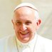
Pope Francis ✔ @Pontifex How beautiful would it be to leave the world a better place than the way we found it. 4:30 AM - 28 Sep 2016
- Retweets 19,654 Likes 39,102
Purpose of Joint Consultation Conference: To appreciate and amplify “the impact of the Encyclical Letter Laudato Si’, the scientific consensus it reflects, the ethical guidance it offers, the economic and social changes it requires and calls for. All this should shed abundant light on the challenges which COP22 must take up during its sessions in Morocco, 7-18 November 2016.” (In advance of the conference, participants submitted papers on this theme that were then shared to all attendees by being presented on a jump drive with the day’s program.)

Proceedings:
Opening: Welcome and Outlining of Seriousness of Situation
The conference was called into session and participants were welcomed by Bishop Marcelo Sánchez Sorondo, Chancellor of The Pontifical Academy of Sciences; Cardinal Peter K.A. Turkson, President of the Pontifical Council for Justice and Peace; Archbishop Paul R. Gallagher, Secretary for relations with States of the Holy See; and Cardinal Theodore McCarrick, former Archbishop of Newark and Washington, Trustee for Center for Strategic and International Studies. Also accompanying this welcoming group were H.E. Archbishop Silvano Maria Tomasi CS, Secretary for the Pontifical Council for Justice and Peace, and H.Em. Card. Charles Maung Bo, Archbishop of Yangon, Myanmar, member of the Pontifical Council on Culture. They emphasized the importance of this conference for preparing for the UN Conference and moving forward with dissemination of the important concepts in Laudato Si’.
The disparities in the world were stated in real terms of the effects of climate changes and tragic weather outbursts on the poor. Humanity must change with an education in integral ecology that sees all the connections between our actions, natural systems and species, economics, social systems, and poverty. There was a call for an alliance between science, policy, and religion to protect the environment. Cardinal McCarrick made the poetic statement that Laudato Si’ was “singing a song of life, wisdom, and reality.” The Cry of the Earth Is the Cry of the Poor.
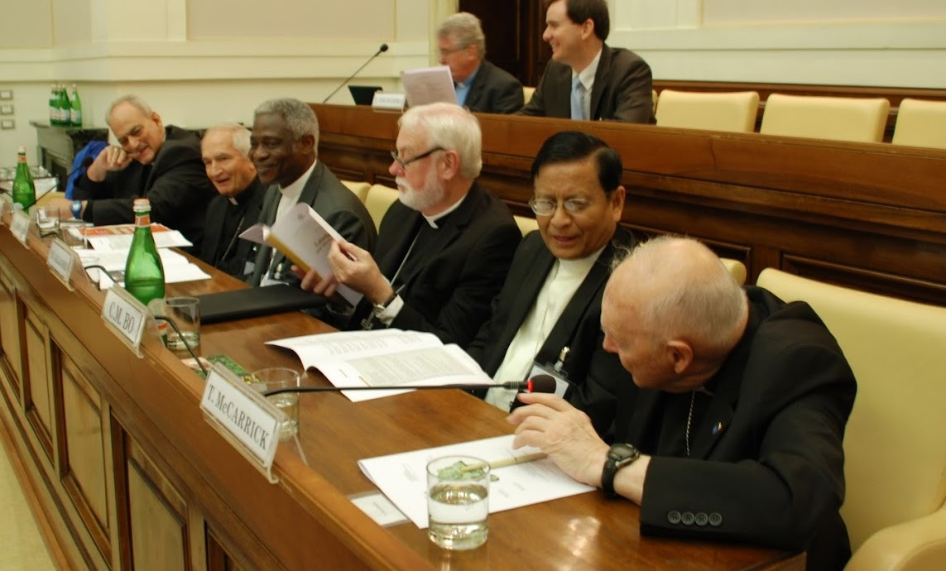
Bishop Marcelo Sánchez Sorondo, H.E. Archbishop Silvano Maria Tomasi CS, Cardinal Peter K.A. Turkson, Archbishop Paul R. Gallagher, H.Em. Card. Charles Maung Bo, and Cardinal Theodore McCarrick,

PANEL 1 SESSION: THE SCIENTIFIC COMMUNITY AND THE ENVIRONMENT SCIENTIFIC COMMUNITY
Moderator: Engineer Tullio Pagano, Researcher, Designer, Implementer, and Energy Manager of Innovative Energy Systems with Efficiencies and Alternatives, AMG Energia
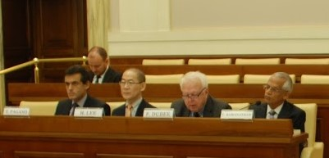
Engineer Tullio Pagano; Dr. Hoesung Lee, Prof. Frederick Dubee, and Prof. Ramanathan Veerabhadran

First Panelist: Prof. Ramanathan Veerabhadran, Distinguished Professor of Climate Science at University of California; Council member of the Pontifical Academy of Sciences, Distinguished Professor, Scripps Institution of Oceanography, University of California at San Diego; UNESCO Professor of Climate and Policy, TERI University, Delhi, India. He presented on “The Encyclical and the Current Horizons of Scientific Research.”
Professor Veerabhadran showed a graphic of temperatures from 50,000 years ago until the present as kind of cyclical tube, where the temperatures from the past moved in regular swirls of temperature until we reach the last centuries where our current trends have soared completely out of the natural ranges. He described the fate of the glaciers (how Glacier National Park will have none soon) and how things are going to accelerate with the melting of sea ice releasing deep sea methane. He cited how 1 billion people produce and use most of the world’s fossil fuels in relative luxury while 3 billion people in the world have no access to fossil fuels or their energies and yet they are the ones bearing the burdens of the devastation from them in terms of rising and acidifying seas, hurricanes and typhoons, droughts and famine, wildfires, blizzards, and so much more. He said the “cry of the earth and the cry of the poor must be heard together” and we need to develop circular models of technology and production where we accommodate for our waste and put them back into use. We need to focus on getting clean renewable low cost energy access to the 3 billion left behind and get the affluent 1 billion to change their energy base and handle their wastes and pollutants to stop the destruction the atmosphere, fresh water sources, land, oceans, and our foods.
He called for 1) Societal Tranformation toward circular models, systems thinking, and caring; 2) Cradle to Grave Education about science and connections; 3) Moral and Ethical Restoration and Service that care for the natural systems along with people
Second Panelist: Prof. Frederick Dubee, Senior Advisor of United Nations Global Impact, Professor at Beijing Genomics Institute (BGI), member of the BGI International Advisory Board/ Think Tank, consultant with the China Biodiversity Conservation and Green Development Foundation (CBCGDF). He presented “The Perspective of a Chinese Non-Governmental Organization”
Professor Dubee read the moving statement of Mr. Hu Deping from the CBCGDF who expressed his regret for not being able to be at the conference in person and his great admiration for Laudato Si and its principles, which he felt were echoed in Buddhism and other religions of the world. There is a Chinese saying: “when you drink sweet water, don’t forget the spring.” He presented a holistic and proactive approach to biodiversity and green development in China, listing the many practical projects already on the ground at work there, so needed because China has suffered from severe loss of biodiversity and extreme pollution promoting current social unrest. China has already greatly benefitted from the shifts it has been implementing in biodiversity protection and alternative energies. It has a commitment to continuing its “green locomotive.” The CBCGDF nonprofit, working with the China government, has accomplished much. They have saved the Milu deer from extinction and just established the first two preserves in the world for saving “Dark Skies,” which it was celebrating with Dark Skies celebrations. (Later the Secretary-General Dr. Jinfeng Zhou of the CBCGFD presented a gift to Pope Francis. The pope, Cardinal Turkson, and Cardinal McCarrick all expressed great appreciation for the China delegation and its inspiring speech and leadership for the world to follow –this was the first time China participated in one of the Vatican conferences.)

Dr. Hoesung Lee, Chair of the Intergovernmental Panel on Climate Change (IPCC), professor in the economics of climate change, energy and sustainable development in the Graduate School of Energy, Environment, Policy & Technology at Korea University in the Republic of Korea. He presented “The Role of States in the Framework of an International Community.”
Professor Lee provided additional scientific data and insight on the current science on climate change and how dire the situation is, echoing support for education and action, motivating the states to take greater action, not less. He, too, called for solidarity, education and public awareness, and world action. He praised Laudato Si’s role in articulating for the world underlying principles and showing the connections between the science and the effects on people and the world’s future.

Discussion: One participant queried about sunspots and their role in prompting the climatic changes and he asked also about the credibility of some of the science protocols on the climatic science findings. This query was addressed first by Professor Veerabhadran who noted the data on how sunspots had been definitely taken into account into all the climatic and atmospheric studies but their contribution was minor compared to human contributions of fossil fuels to the atmospheric system causing the changes. Dr. Lee addressed the serious and strict protocols for all the studies and their peer reviews, and referred everyone to the many sources and their reproducible and consistent results and intense scrutiny for accuracy and reliability of the studies posted on the internet for scruitiny. Jeffry Sachs noted the new study released in September by Oil Change International that cited that even with only the present carbon and fossil fuel producers, our output would take us beyond 2°C of warming within a decade: http://priceofoil.org/2016/09/22/the-skys-limit-report/
Father Timothy Radcliffe, OP, advocated for more working with organizations run by young adults and youth with their energy to transform the world and get the word. This message was echoed in a call to get the Catholic education systems from the grade schools to the universities working to build understanding, awareness, and action according to the science, moral and faith principles,and systems thinking of “Laudato Si”, and that these shifts must propel and extend all academic disciplines into sustainability and more future oriented, long-term thinking, innovations, and solidarity. The conversation also included recommendations to ask every nation of the world to have a “State of the Climate” address to their people and use a media campaign to make the heart and mind connections between the science and the poor and to everyday signs of the climatic changes happening in people’s lives within the nation and around the world, and their specific effects on economies, landscapes, jobs, etc. The nations could use TV, radio, and social media tools in campaigns of caring and awareness.
The Catholic Church could do something similar, as with the Rice Bowl campaign and others. Restoration, reforestation, and regreening in grasslands also need to be on the docket to absorb the carbon, not just stopping the input of fossil fuels. Nations and nonprofits must institute programs that engage the unemployed (especially women and children and young adults) in restoration based upon the proven models of Wangari Maathai’s Green Belt Movement and the US Civilian Conservation Corps and Youth Conservation Corps, among others. And the Catholic Church needs to launch a major Divestment-Reinvestment Campaign based on the Gospel teaching of where your treasure is there your heart is also (Matthew 6:21). It was observed that apartheid in South Africa did not fall until there was the worldwide divestment campaign. If Catholic institutions, organizations, healthcare facilities, dioceses, universities, and believers shifted their investments out of fossil fuels into alternatives and socially responsible funds, we could lead the world and the shift would occur and rapidly. This was a concept that was repeated and affirmed by participants throughout the conference.

PANEL 2 SESSION: THE CALL FOR INTEGRAL ECOLOGY
Moderator: Sister Shelia Kinsey FCJM; Executive co-secretary of the inter-Congregational; Justice, Peace, and Integrity of Creation (JPIC) Secretariat
Dr. Peter (Pedro) Walpole, SJ, forest hydrologist, Director of Research at the Institute of Environmental Science for Social Change in the Philippines and Coordinator of Reconciliation with Creation for the Jesuit Conference Asia Pacific. “A Vision from the Field: Climate Challenges in Developing Countries”
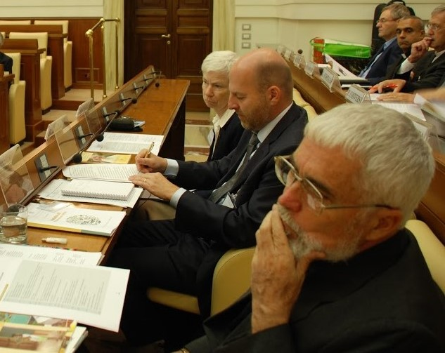
Dr. Peter (Pedro) Walpole, SJ (forefront); Mr. Bern Nilles; Sister Sheila Kinsey, FCJM (Professor Zamagni is missing)

Father Pedro began his talk with a tragic story of loss of hope in the face of all the pressures from rising seas and refugees in their own lands of the Philippines where he has spent decades. A mother of four recently killed her children and then herself, and her husband followed the next day. This is the vision of desperation from the field, and the people of his country are all struggling with adaptation as they are not the ones who are causing the changes.
He emphasized the need for vision and action in four areas:
- Climate Change and Resilience – how to help the poor adapt while changing the status quo of continuing the destruction by the affluent
- Restoration of Forest Cover – which he is working with the youth and people of the Philippines to accomplish
- Ensuring Food Security and Family Farms—analyzing the means of production and distribution to meet people’s needs and reduce waste
- Preserving Cultural Wealth—the passing on of wisdom, traditions, celebrations that bind people together and also their ecological and economic understandings and participation

Father Walpole told of the tragedy of the Typhoon Haiyan -- even when people were alerted in some locations in the Philippines that the disaster is coming, they did not know have methods of actions to prevent the disaster, as there was little not room to avoid the storm or live beyond the reach of the waters for the majority of residents. “Knowledge is not action”, and we need also the commitments and abilities of the world to act by defining responsibilities and protocols. We need to move forward by applying the precautionary principle with respect and care, establishing new forms of governmental structures and response paradigms, low carbon economies and lifestyles, and science where people matter.

He emphasized the role of forests and the need to stop deforestation and reforest, adapting to growing trees on steeper slopes by involving communities and youth in forestry – 60% of medicines come from the forests for the local people –the forests are the water sources and medicine cabinets of the local people besides providing the ecological services of absorbing carbon, holding down the soils, improving hydrology, etc. Education around the world must focus on service and ethics, not just excellence.

He urged the world not to engage in the language of crisis and uncontrollability but rather roadmaps and scenario planning, deeper and more community sense and communities of practice, a simplification of lives and lifestyles – and of felt compassion. Like Popes John Paul II and Francis, he called for ecological conversion –on the personal, national, and world levels-- into gratitude, recognition that the world is a gift, and compassion –an evolution of tenderness.

Prof. Stefano Zamagni, Member of the Pontifical Academy of Sciences, senior professor and former Dean of economics at University of Bologna; Vice Director, SAIS BolognaProfessor of International Political Economy alla Johns Hopkins University, Bologna Center. He presented “Climate Change and the Economics.”

Professor Zamagni stated that “human and natural environments degrade together,” and we are as a globe experiencing severe “climatical inequality.” For example, the average Chinese contributes 6.2 tonnes of carbon/fossil fuels per year while an average North American contributes 22 tonness. This is sad realities of “consumption math.”

He said that we need to move from the dialog about the natural world or ecosystems being either a public or private goods, but rather into the Laudato Si understanding of it as a “common good.” We need a green economy, blue economy, and circular economy. We need to transform our wastes into cycles of regeneration and reuse and transformed energy, as is done in the natural world – instead of as linear production and economic streams that turn the natural world into waste in their wake; and we need big money to make this transition. He called for a World Environmental Organization like the World Bank and World Trade Organization to oversee the common good of our ecology --guiding the investments and transformations into circular economies and production streams.

Mr. Bernd Nilles, Secretrary General of CDISE --an international alliance of Catholic development agencies working together for global justice—and member of the board of Climate Action Network Europe. He presented “Solidarity Facing the Impacts of Climate Change.”

Coming from the perspective of global Catholic Social Relief Services and other Catholic development organizations, Secretary General Nilles stated how deeply we need to be building concrete solidarity about poverty and climate change and the suffering. Sadly, much of the good work of development that has been done in the past is now being washed away because of climatic shifts and disruptions along with other effects of the atmospheric fossil fuels; and today’s financial systems are not working for the poor but against them. In the affluent countries of the world, there is the plague of overconsumption that is eating up our future, and we need instead to build inter-nation and intergenerational justice and solidarity.

He observed that responses and solutions are best when they build upon good that already exists and they start from communities; we need to fund solutions that are built from ground up, but these are not getting funding now; these solutions are being dismissed. We need to give the most affected communities voice, and we need to bring back a spirit of mission, not just about industrial pollution but around agriculture and other land issues, including forestry and restoration.

Discussion: Once again the conversation and queries were far ranging and resounding were the themes of divestment/reinvestment campaigns and utilizing our Catholic education system to lead in this transformation and educational awareness building—especially utilizing our universities, but beginning with our grade schools, high schools, and parishes. There was a dialog about whether it is best to focus on mitigation or prevention of climatic changes; but it was clear that both are essential since the suffering of rising tides and intense storms and melting tundra, etc., is already upon us. Father Pedro spoke eloquently about this, but it was emphasized over and over by many that we must do what we can to slow the changes and turn the trends around in the spirit of Laudato Si within the Catholic Church and on the world stage.

The related issue of the economic devastation of the waste of people’s energies as well as those of planet was brought up--how the move to robots and replacing people with automation, and the cutting of jobs to feed the stock value and corporate and financial leaders were all part of the untenable, problematic economy of waste and overconsumption by the few to the devastation of the many. A new paradigm of solidarity, sharing, and shared responsibility is needed instead of the current paradigms of greed and accumulation of wealth that affects society, economies, and the environment. So a new definition of what real “growth” is must come from nations in their GPDs and from businesses and corporations in the accounting of their bottom lines. What is it we are growing in? How can values be integrated? How do we change our definitions to fit including people and the planet into the assessments and financial and social accounting systems and analysis?

PANEL 3 SESSION: DRAWING NEAR COP22
Moderator: Mariagrazia Midulla, head of climate and energy at World Wildlife Fund (WWF) Italy – she gave a very passionate plea to do the work of Laudato Si and why it was so important for our future.
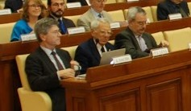
Prof. Jeffrey D. Sachs; Prof. Pierre J. Léna; and Dr. Braulio Ferreira de Souza Dias

Professor Jeffrey D. Sachs, Director, The Earth Institute, Columbia University, University Professor in economics, Quetelet Professor of Sustainable Development at Columbia's School of International and Public Affairs and a professor of health policy and management at Columbia's School of Public Health: Special UN adviser on the Millennium Development Goals. He presented “The Radical Vision of Laudato Si’.”

Professor Sachs gave a summation of how groundbreaking the Paris agreements are and the legal tools they offer the world community, but also how much they must be pushed to go further. He cited the Oil Change International finding again that we must not merely stay at the status quo but radically reduce the current use of fossil fuel energies to keep warming below 1.5 degrees. So we will need a carbon budget, where we cut our current carbon use to 2/3 at least. If not, we will overreach the temperature rise within a decade.

So that means swift and decisive plans, commitments, and modes of action, much bolder than the nations have yet imagined. Now that there is a working agreement, it is possible to be more bold in our imaginations. Also, as nations that are turning to alternative fuels are seeing the economic and social benefits, they are actively seeking more investment in alternatives, such as in China and Germany. These models of success with economic and social benefits provide incentives to others.

He said we would also need dramatic worldwide investments in Adaptation and Resiliency, and financial and technological support needs morally and practically to go from the affluent nations to the poorer countries bearing the brunt of the damage. This is, of course, a hard sell and difficult scenario. The US and other affluent countries with high carbon/fossil fuel production, combustion, and consumption are resistant to paying for the destruction and helping the poor nations. Laudato Si and the Catholic Church with its leadership and network of education and awareness building could push, along with other religious groups, to make this moral case on the world stage.

The rich nations also need to help the poorer nations invest in low carbon energy so they can have access to development without causing the same damage the fossil fuel based affluent nations have already caused.

Finally, a fourth of the fossil fuel equation falls into land use, by Sachs accounting, and the agricultural systems must be changed to stop being based in fossil fuels and chemicals, and there must be a global push for reforestation and restoration of grasslands and the oceans have to restore and reenergize our carbon absorbers for carbon sequestration, community health, biodiversity, and fresh water sources.

So he called for a movement to “Defend Paris Agreements and Defend Implementation” and offer movement for greater goals and mobilization.

He counseled that the complexity of the challenges is immense because we have to transform world energy systems while not allowing economies and nations to collapse into conflicts – we “need to have patience as nations survive the surgery” shifting as we shut down carbon producers and start up alternative.

Governments do not have long terms plans, but religion does…Laudato Si is a promoter of the long view and the positive end goals…and is a raiser of the boats of public and religious opinion. Sachs echoed the call to mobilize the Catholic parish and education system around the world in this effort.

He said it was hopeful how many had ratified the Paris agreement and that there would be practical solutions-based conferences held by engineers and educators in November in Morocco, the first conferences of these kinds to develop working tools for the nations to use held alongside the climate talks

Prof. Pierre J. Léna, member of the Pontifical Academy of Sciences and French Academy of Science, part of the Foundation La Main a la Pate to rejuvenate science education; Professor Emeritus University of Paris, Diderot, Officer in France’s Legion of Honor; professor of the Paris Observatory Department of Space Research; 2005 president of the Comité d’Éthique (COMETS) of the CNRS. He presented
“The Educational Challenge of COP22”

Professor Lena laid out the challenges of the need for stronger science education worldwide to help everyday people and the new generations being raised to understand climate change and its causes and its systematic effects of the poor, other species, fresh water systems, the oceans, and the future. But he said that what is needed goes beyond science into ethics, and Laudato Si laid out these connections. Science education needs to go beyond data acquisition into ethical understandings and application to help students make connections to the relationships. He gave us the image that a school girl had offered of a carbon handprint as a symbol of our positive contributions to helping heal the world (planting trees, recycling, using alternatives, reducing energy) while our carbon footprint is a symbol of the negative effects.
We must integrate the science and economy of restoration into our land use accounting, our positive handprints.
There needs to a worldwide consensus on the problems but also on the universal moral values. Laudato Si helps moves this conversation forward. He said we must “hear the cry of the earth, hear the cry of the poor.”

Dr. Braulio Ferreira de Souza Dias, Executive Secretary of the Convention on Biological Diversity (based in Montreal), Former Secretary of Biodiversity and Forests at the Brazilian Ministry of the Environment and member ofBrazilian Delegation for the United Nations Conference on Environment and Development in Rio de Janeiro. He presented “COP22 and Biodiversity.”
Dr. Ferreira de Souza Dias stated that some of the key principles that need to emphasized in the COP22 talks as we work to preserve atmospheric health and forestall dramatic climatic changes are the following:
- Work to conserve biodiversity from the onslaughts of climate changes that affect the weather and migrations paths on land and in the oceans, which also encourage invasive species to run rampant, pushing out native species that are stressed from changes
- Ensure that all uses of biological species be sustainably collected, without overuse or abuse that decimates species populations/habitats/ecosystems
- Ensure the economic benefits of any use of biological treasures go to the local communities, especially the indigenous communities, whose rights are being taken away (their rights must be protected worldwide and in each nation)
- Ensure gender equality and rights as communities that educate women have more sustainable populations and cared for children, public health, and biodiversity/ecosystems
- Stop biodiversion and harm to endangered species
- Be careful custodians of our genetic resources, saving species and seed banks, and ensuring the fair share of users and access, and the financial gain going to the local communities fairly
We need to push for ratification of the Convention on Biological Diversity, but key players have not yet signed including the Holy See and the US, and the spirit of Laudato Si declares the necessity of such actions.

Discussion: Professor Simona Beretta thanked the experts for their work and contributions and called for messages to be conveyed in simple, heart-felt core language for ease of understanding—nothing simplistic in terms of message or data, but understandable communication. She asked us always to remember to get to the heart of things so that the scientific, economic, and social statistics doesn’t obscure the core facts of suffering and empathetic need for actions on all levels.
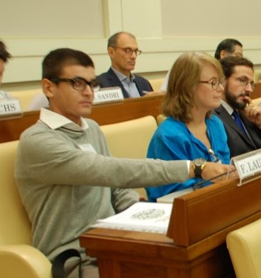
Judge Amedeo Postiglione (the Founder and Director of the International Court of the Environment Foundation and Vice President of the EU Forum of Judges for Environment) and Tomas Insula (cofounder and coordinator of the Global Catholic Climate Movement) Both made passionate pleas for action on many fronts, including divestment/reinvestment campaigns and education. These were affirmed as some of the strongest tools to get the rapid change in values and vision, public opinion, corporate assets allocation, and shift to the future. Father Seán McDonagh SSC (theologian and author of numerous books on the environment and call of faith--Climate Change: The Challenge to All of Us, Greening the Christian Millennium, Care for the Earth and Dying for Water) recommended bishop synods on Laudato Si need to be planned in every region of the world to begin the process of having the Church leaders, institutions, and believers more involved in the Laudato Si Catholic movement based in the call of Gospel faith and responsibility.

Francesco Laureti, an 18-year-old Italian student read his statement telling about how at his Catholic school in Italy no one was talking about Laudato Si so he felt compelled to work with his teacher on classes on the encyclical but his fellow students didn’t care at first because they were too occupied with their technology. He asked that Laudato Si be integrated into all of the Catholic education system quickly as the future depends on it.

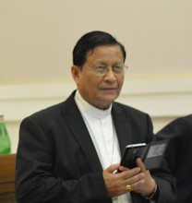
H.Em. Card. Charles Maung Bo, Archbishop of Yangon, Myanmar, spoke powerfully towards the end of the day-long conference from the base of what he had witnessed in his region of the world. He called the death and suffering from climatic changes as a genocide that rich countries were inflicting on the poor. He abhorred the “casualness of how we accept the casualties of the poor.” He felt that disseminating Laudato Si and the upcoming climate talks and all the efforts to educate others and build awareness and action might be able to change this. There are unsung saints and martyrs around the world working to save their land and waters, and we must stand with them, not against them.

At the end of the day, the Holy See presented its succinct diplomatic statement that encompassed many of the key principles about what the nations of the world must do, encompassing the key points of this line of discussion from the conference. The statement and signers can be found at: http://www.pas.va/content/accademia/en/events/2016/cop22/final_statement.html

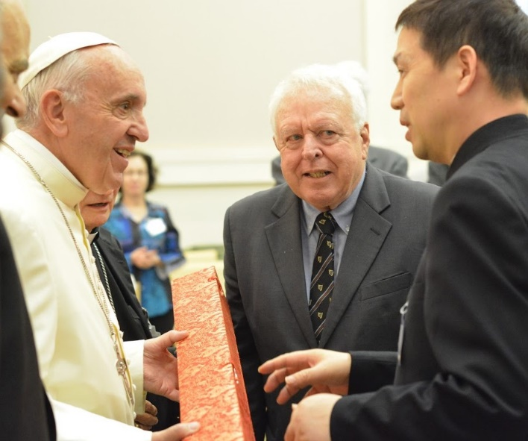
The highlight at the end of the day was, of course, the visit of His Holy Father Pope Francis. He spoke humbly and with great compassion, thanking all participants for coming and emphasizing how important these issues are to reduce the suffering of the poor and how if we do not change, we may not have a world for children in the future. He told us "This [climate change] is a human problem, it's our problem, so we should solve it. And it grows poverty and misery in the world, that's why I'm so worried about it."
That same day, Pope Francis tweeted, "How beautiful would it be to leave the world a better place than the way we found it." --
The National Catholic Reporter stated that this was one of his most retweeted comments of the year.

After speaking to the group, he met everyone and spent a few moments speaking to each person. The Chinese delegation offered him a gift, as did many others.
Some of the photographic highlights follow. These photographs are courtesy of the Pontifical Academy of Sciences. As the summation of this conference was based on jotted notes rather than a transcription, they are to be considered point-blank accurate…they are accurate in spirit and overall content but not necessarily in detailed specifics.

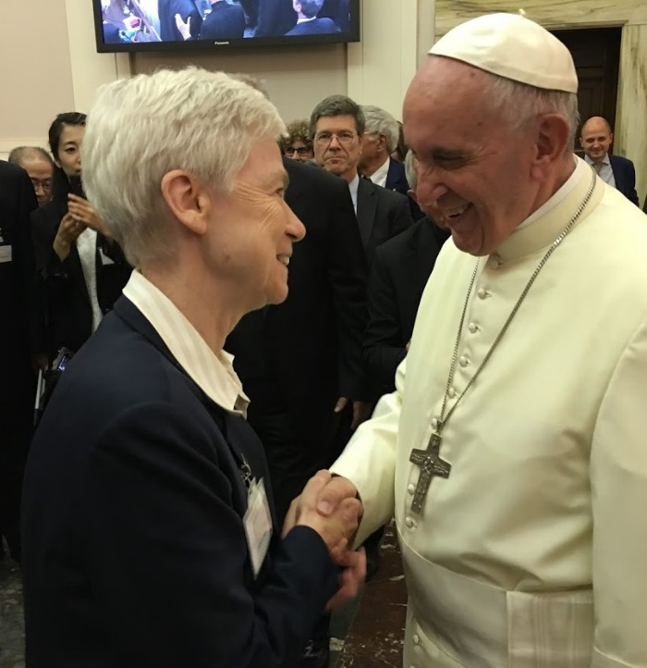
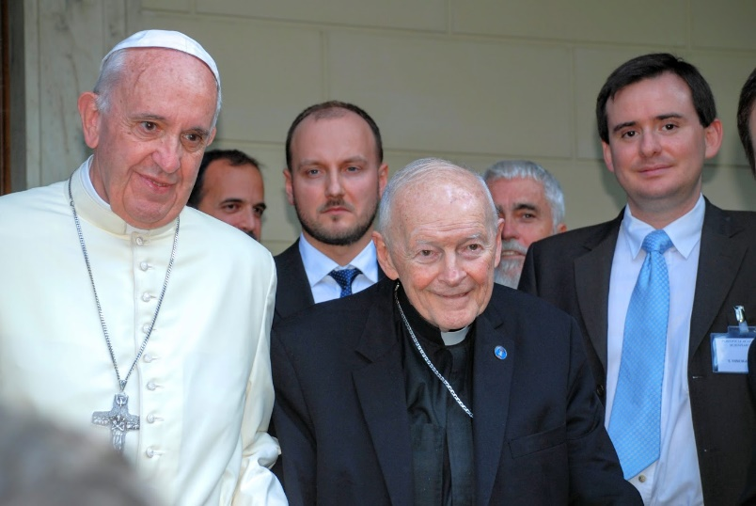

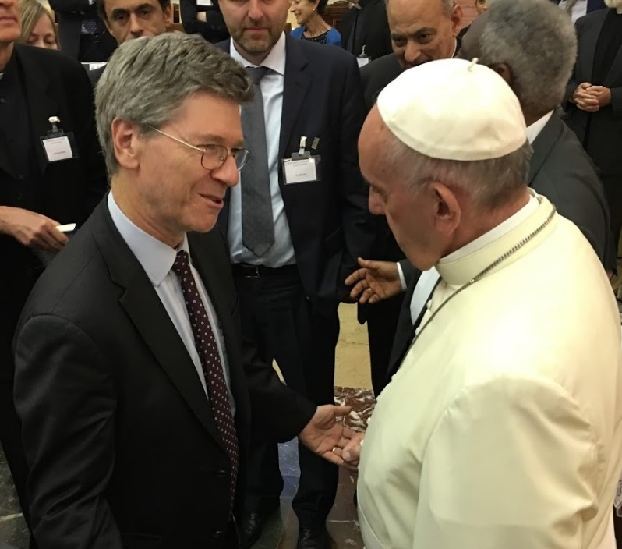
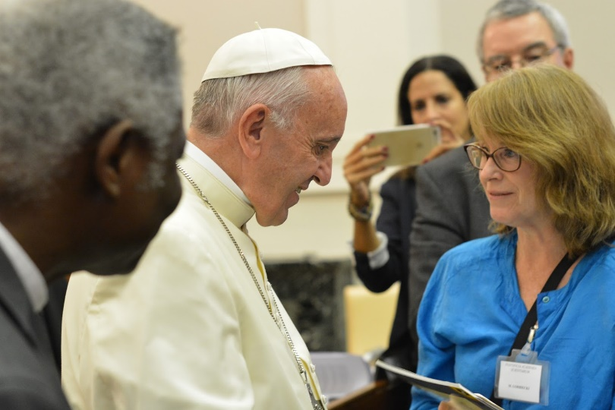

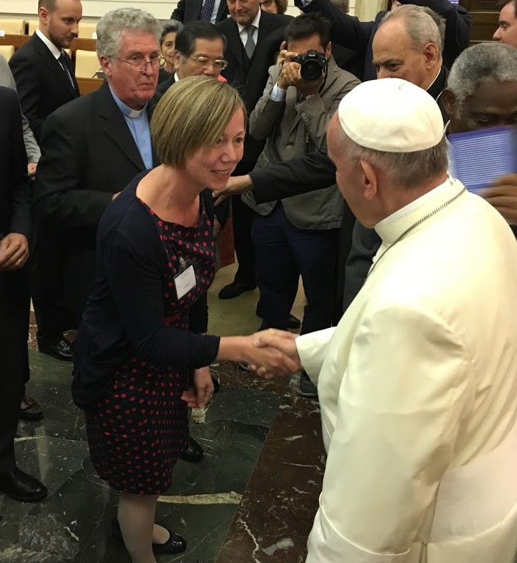

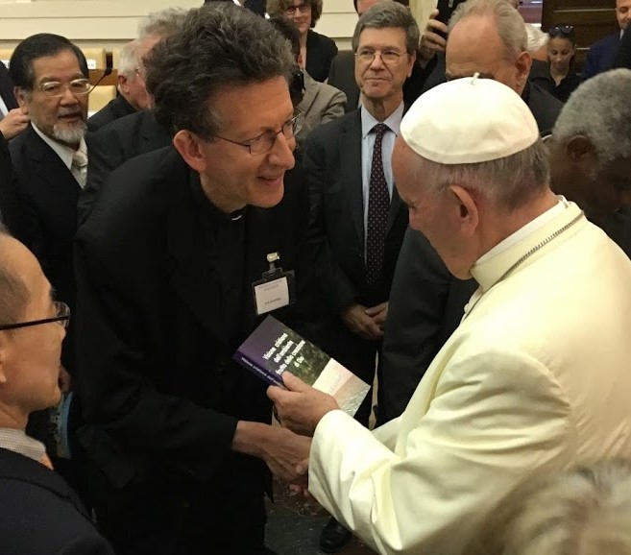

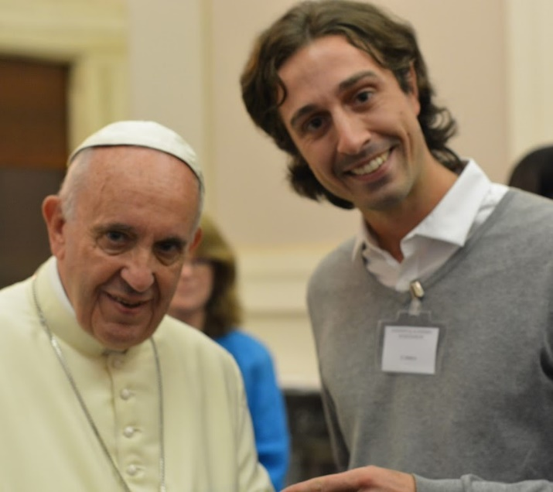

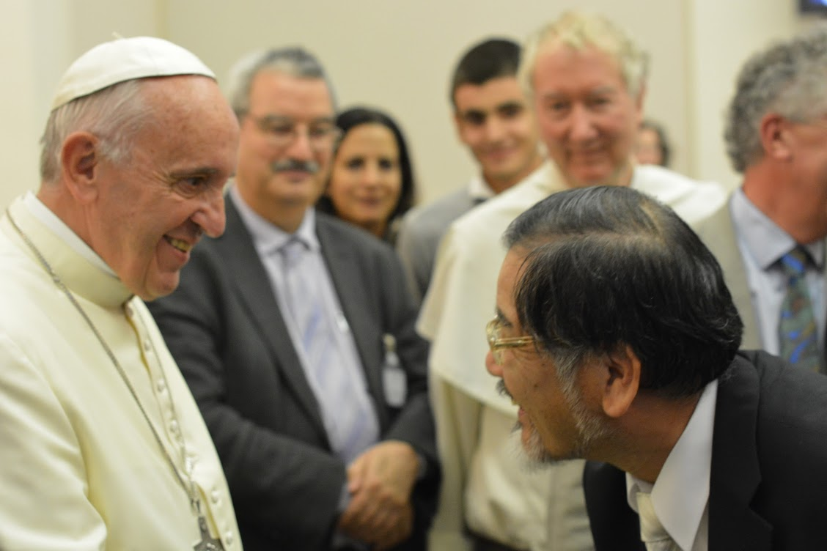
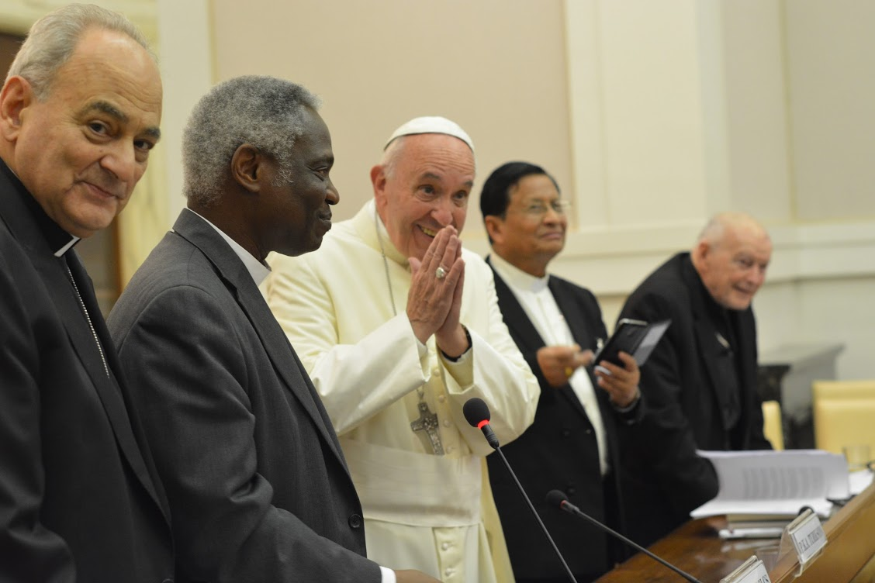

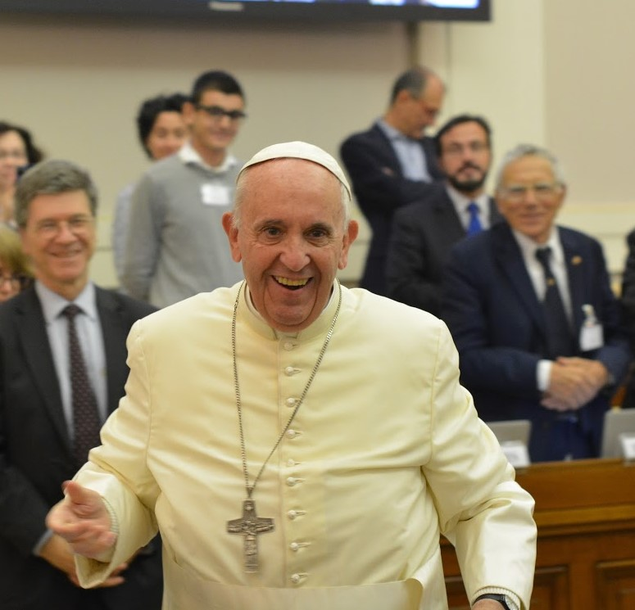
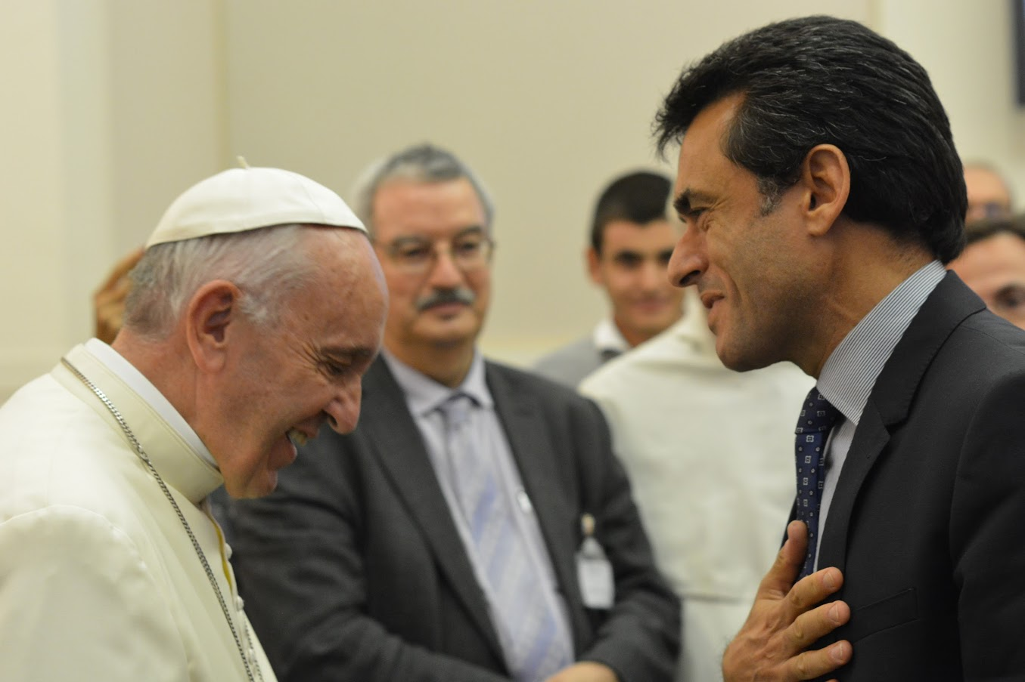

Cardinal Theodore McCarrick and Pope Francis
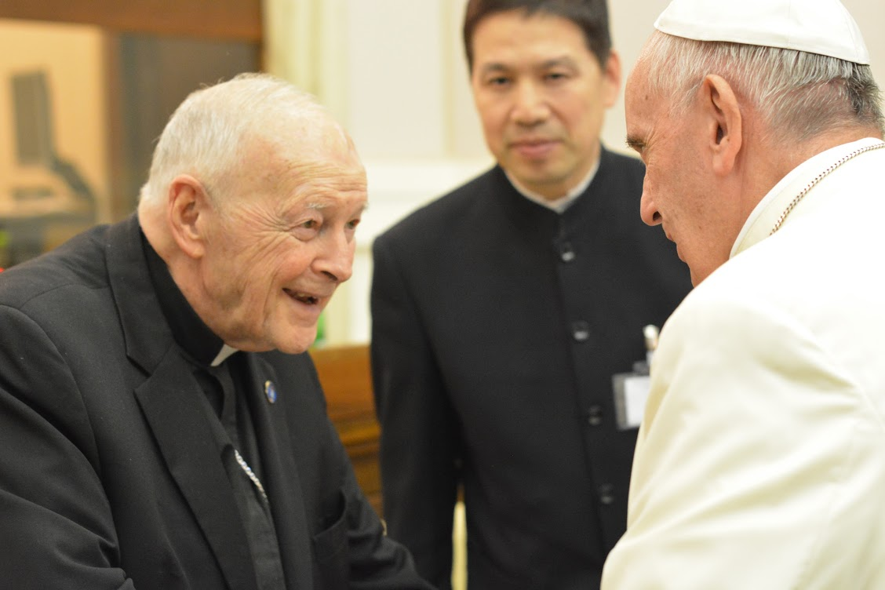
Non-Panelist Participants

Dr. Anthony Annett, Climate Change and Sustainable Development Advisor at the Earth Institute, Columbia University
Professor Simona Beretta, Political Science Faculty, Università Cattolica del Sacro Cuore of Milan, and Consultor of the Pontifical Council for Justice and Peace
Dr. Paolo Conversi, Official of the Secretariat of State of the holy See
Fr. Giacomo Costa SJ, Director of Aggiornamenti Sociali (Jesuit publication)
Engineer Stanislas de Larminat, Author
Father Dr. Bruno-Marie Duffé, Member of the French Justice and Peace Commission
Msgr. Anthony Figueiredo, Assistant to Cardinal McCarrick
Mr. Paolo Foglizzo, Member of the Editorial Board, Aggiornamenti Sociali

Ms. Flaminia Giovanelli, Under-Secretary, Pontifical Council for Justice and Peace

Dr. Lorna Gold, head of Policy and Advocacy, Trócaire (Caritas Ireland)

Professor Father Paul M. Haffner, Faculty of Theology, Gregorian University

Mr. Tomás Insua, Coordinator of the Global Catholic Climate Movement

Dr. Zhou Jinfeng, Secretary General, China Biodiversity Conservation and Green Development Foundation

Ms. Jinmi Kim, Special Assistant to the Chair of the IPCC

Fr. Giuseppe Koch SJ, Astronomer of the Specola (Vatican Observatory)

Professor Father Joshtrom Isaac Kureethadam SJ, Faculty of Philosophy, Salesian Pontifical University

Mr. Francesco Laureti, Student

Ms. Marybeth Lorbiecki, Director of Interfaith Oceans

Professor Massimo Losito, Faculty of Bioethics, Pontifical Athenaeum Regina Apostolorum

Mr. Jonathan Lynn, Head of Communications and Media relations, IPCC Secretariat

Fr. Seán McDonagh SSC, Theologian

H.E. Archbishop Michele Pennisi, Archbishop of Monreale in Italy, and Member of the Pontifical Council for Justice and Peace

Judge Amedeo Postiglione, Founder and Director of the International Court of the Environment Foundation, Vice President of the EU Forum of Judges for Environment

Fr. Timothy Radcliffe OP, Director of the Las Casas Institute of Blackfriars in Oxford

Dr. Sonia Ehrlich Sachs, Director of Health Sector, Earth Institute, Columbia University

Ms. Simonetta Sandri, Sustainability Special Initiatives, ENI

Eng. Gianni Silvestrini, Scientific Director of the Kyoto Club (Italian association)

Mr. Andrea Stocchiero, Policy officer for the Italian Federation of Christian Organizations for International Volunteer Service (FOCSIV)

Mr. Tebaldo Vinciguerra, Official of the Pontifical Council for Justice and Peace

Prof. Takaaki Pio Yasuoka, honorary member of the Institute of Global Concern, Sophia University in Japan, and Consultor of the Pontifical Council for Justice and Peace
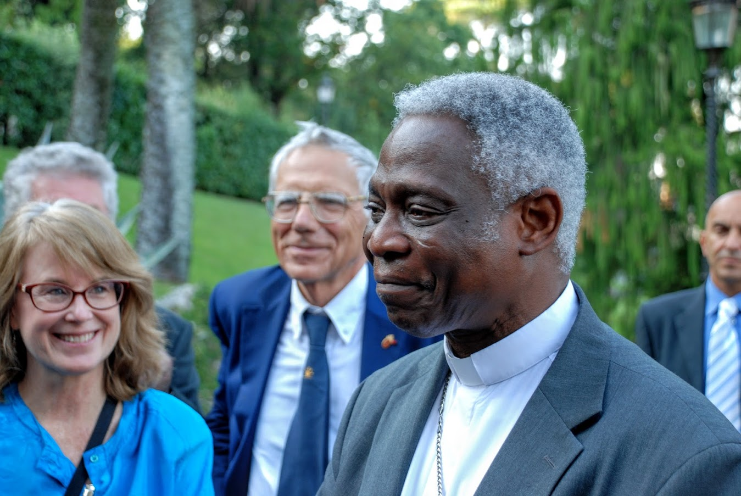

Special thanks to Cardinal Peter Turkson who, with his staff at the Pontifical Council of Justice and Peace, organized the conference with the Pontifical Academy of the Sciences and the Holy See.
The feast day was that of Our Mother Mary, Undoer of Knots, a favorite feast day of Pope Francis. It is appropriate that this conference occurred on this feast day, as we need great prayers to help our world untie the complex knots of our relationships and responsibilities in terms of fossil fuels, pollution, consumption and caring for our world, the poor, other species, and generations to come.

